Play Ball!
19th

Annual Menomonee Falls
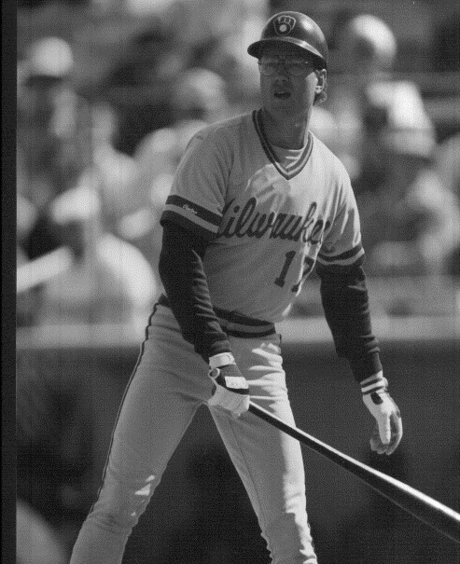
Gantner – August
Baseball Camp

July 13 – 15, 2020
Time: 9 am-1:30 pm

Place: Menomonee Falls Little League Complex
Milwaukee Brewers 17 Years played ( Mill Road between Pilgrim Road & Lilly Road ) Milwaukee Brewers 4 Years Pitched
1982 World Series 1984 U.S. Olympic Baseball Team
Milwaukee Brewers Coach AGES 8-12 on the lower fields 60’ bases & 46’ mound Menomonee Falls H.S. Coach
AGES 13-up on the upper fields 90’bases & 60’6’’ mound
Pre-registration required,
enrollment will be limited so sign up early.
Price : $140 (After June 30th call to check for availability)

Questions? Call 262-751-8212
* B r i n g y o u r o w n g l o v e, b a t, b a s e b a l l s h o e s, l u n c h & w a t e r.
-------------------------------------------------------------------------------------------------------------------------------

Menomonee Falls Registration Form
Name _________________________________________ Age ____________

Address, city, and zip________________________________________________________________________________

Phone _________________________________________ Evening phone_____________________________________

E-mail _________________________________________ T-shirt size (adult size): S M L XL
Waiver: I hereby authorize the personnel at the baseball camp to act for me according to their best judgment in any emergency requiring medical
attention. I hereby waive and release the camp, its affiliates, and all agents from any and all liability for any injuries incurred while at camp.

Parent signature___________________________________________________ Date _____________________________

Make check payable to Don August and send to: N74 W15696 Stonewood Drive, Menomonee Falls, WI 53051

